**COS30019 – Final Assessment**

**Answering Instructions:**

Please do not use a red pen/type in red.

**There are 5 problems.**

Total marks on paper: 90 + 8 bonus marks

The maximum mark you can get for the final assessment is 90 (100%). However, if you lose marks in some questions and you get the bonus marks, the bonus marks will be added to your total of the final assessment.

**Student Name: S M Ragib Rezwan**

**Student ID: 103172423**

**Problem 1 – Propositional Logic (18 marks)**

About the insurance policy the intelligent agent is reviewing, the agent knows the following:

* *IF the* *policy holder has made no insurance claims AND* **(***the policy holder is a new customer OR the policy holder holds multiple policies with the company***)***, THEN the policy holder is eligible for a discount.*
* *The policy holder is NOT eligible for a discount.*
* *The policy holder has made no insurance claims.*

Represent the above knowledge base in propositional logic using the following vocabulary:

(5 marks)

**NC** for *The policy holder has made no insurance claims*,

**NEW** for *The policy holder is a new customer*,

**MP** for *The policy holder holds multiple policies with the company*,

**DC** for *The policy holder is eligible for a discount*.

**Using a truth table**, please answer the following questions:

1. How many models does the knowledge base have? (5 marks)
2. Is the policy holder a new customer? (4 marks)
3. Does policy holder hold multiple policies with the company? (4 marks)

For questions (b) and (c), your answer has to be **Yes** or **No** or **Don’t know**. For instance, if you answer **Yes** to question **1.b.**, you’ll have to demonstrate that the knowledge base entails ‘*The policy holder is a new customer*’; if you answer **No** to question **1.b.**, you’ll have to demonstrate that the knowledge base entails ‘*The policy holder is NOT a new customer*.’ Clearly indicate which **rows** of the truth table support your answer.

(See picture on next page for the answers to question no 1)

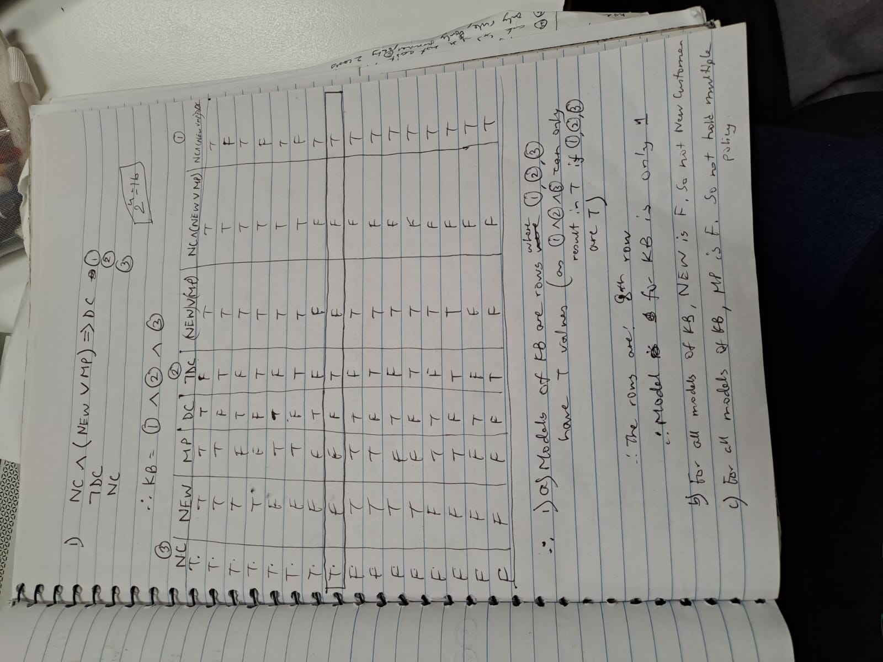

Note: The model is the one seen in 8th row. So only 1 model, and for that New and MP both came F.

**Problem 2 – Propositional Logic (16 marks)**

Decide whether each of the following sentences is **valid**, **unsatisfiable**, or **neither**. Verify your decisions using truth table. Clearly indicate which **rows** of the table support your answer.

1. (¬A ∨ B) ∧ (A ∧ ¬B)
2. (A ∧ ¬B) ⇒ A
3. A ∨ (B ⇒ B)
4. (A ⇒ ¬A) ∧ B

*Hint:* You can use just one truth table for all four sentences.

(4x4=16 marks)

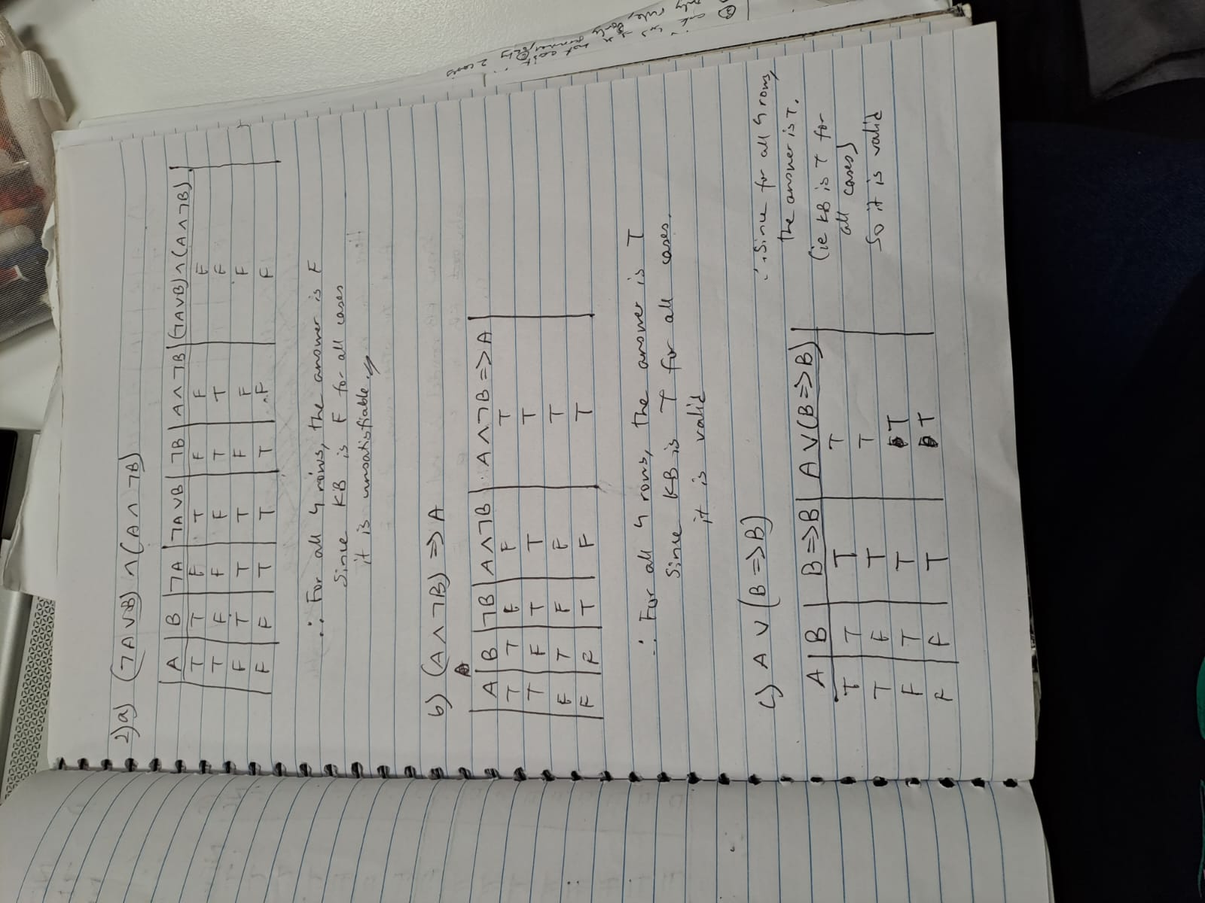

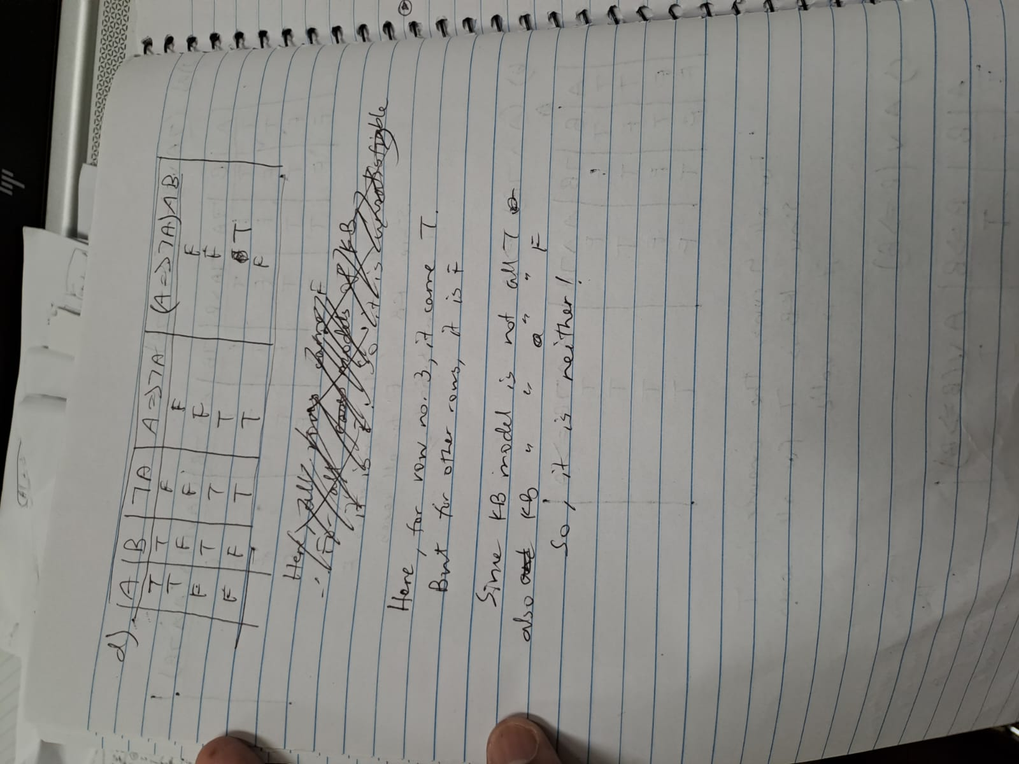

**Problem 3 – First-Order Logic (16 marks)**

Represent the following statements in first-order logic, using the following vocabulary:

**Student**(x): x **is a student**

**Phone**(y): y **is a phone**

**Game**(z): z **is a game**

**Has**(u,v): u **has** v

**Plays**(u,v): u **plays** v

1. Every student has some phones.
2. There is a student who has all games or plays some games.
3. Every student has all games but does not play some games.
4. There is a student who has exactly one phone.

(4+4+4+4 = 16 marks)

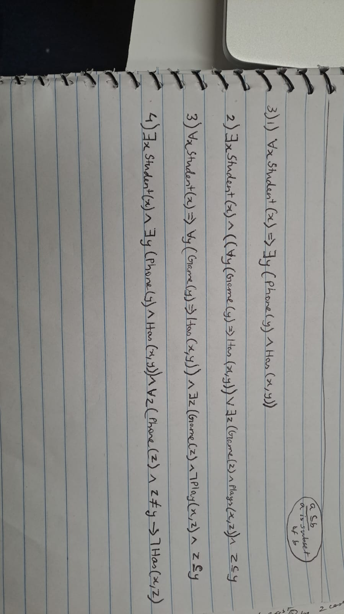

**Problem 4 – AI Planning (25 marks)**

Our agent is a robot with two hands: *Hand1* and *Hand2*. The robot’s task is to tidy up the room by putting rubbish into the *Bin* and putting things at their right places. Initially, the robot is at the *Door*, the *Rubbish* and the *Toy* are at the *Table* and both hands of the robot are free. The right place for the *Toy* is at the *Shelf*. The actions available to the robot include *Go* from one place to another, and *Grasp* or *Ungrasp* an object. Grasping results in holding the object using a free hand if the robot and object are at the same place. One effect of grasping is that the free hand that the robot uses to grasp the object will no longer be free after grasping the object.

1. Write down the initial state description and the agent’s goals. (7 marks)

2. Write down STRIPS-style definitions of the three actions. (9 marks)

3. Write down a consistent partial-order plan (POP) with no open preconditions for this problem. (9 marks)

(*Hint*: You may consider using the following template for question 3 of this problem:

**Actions=**{ Start, Go(Door, Table), …}

**Orderings=**{ Start < Go(Door, Table), …}

**Links**={

Start - RobotAt(Door)-> Go(Door, Table), … }

**Open preconditions={…}**

And complete it with your answer.

You may also want to include a hand-drawn diagram showing the partial-order plan POP if you wish.)

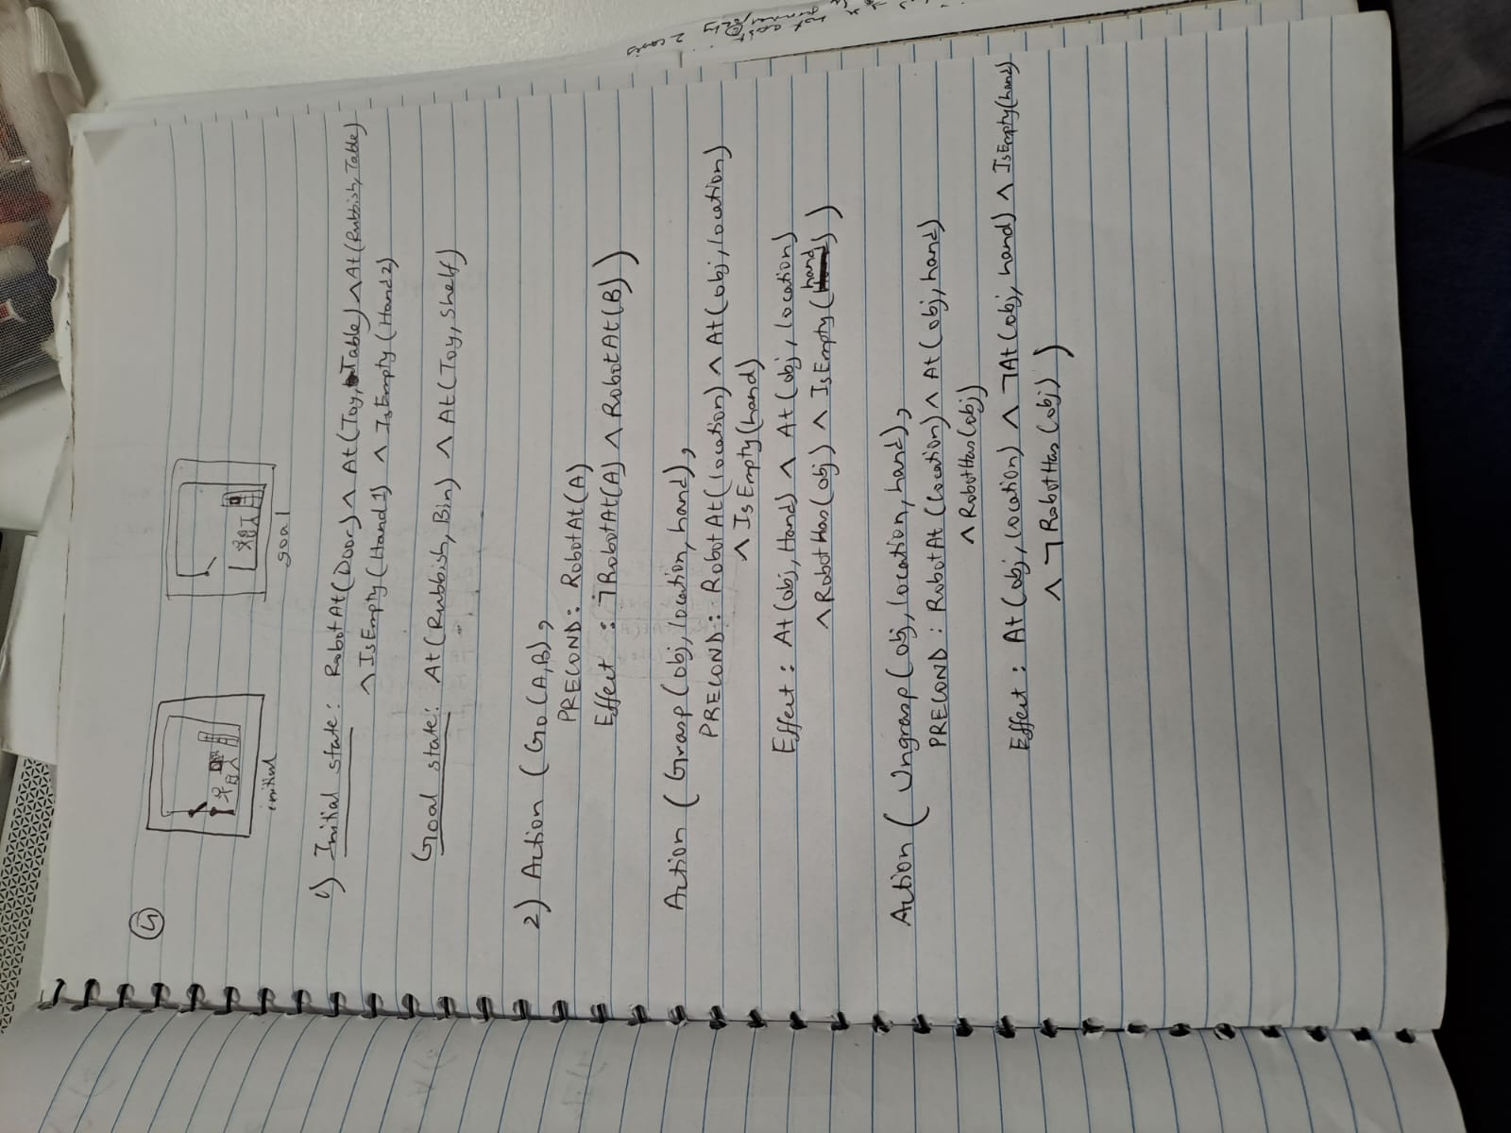

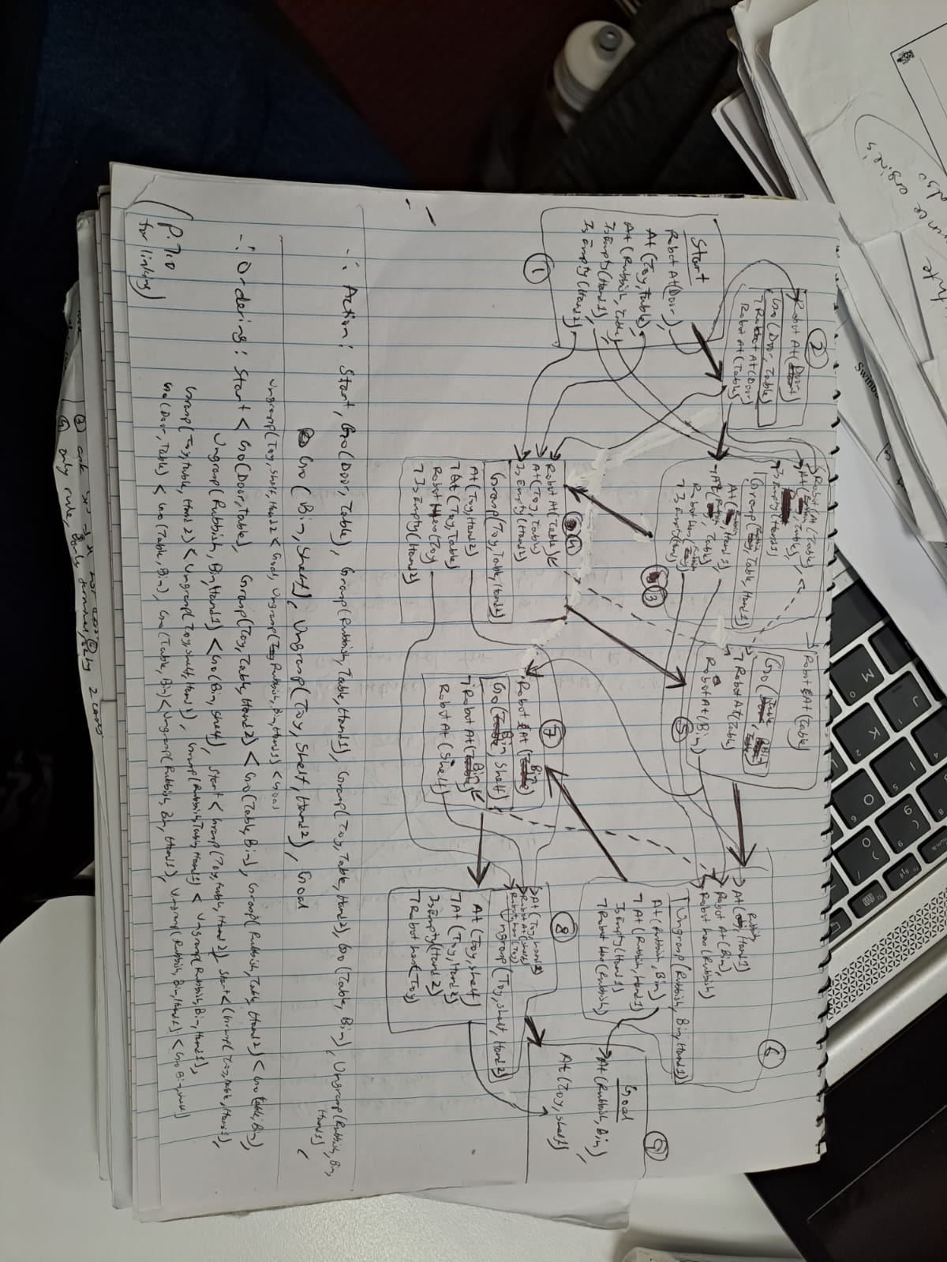

Here the **small/light coloured arrows** shows **closing of preconditions**,

The **dotted arrows represents** the **conflicts that had occurred**,

The **dark black arrow (along with the numbering)** represents the **order of the actions from start to end.**

Overall, the action plan will be: Start, Go(Door, Table), Grasp(Rubbish, Table, Hand1), Grasp(Toy, Table, Hand2), Go(Table, Bin), Ungrasp(Rubbish, Bin, Hand1), Go(Bin, Shelf), Ungrasp(Toy, Shelf, Hand2), Goal

Note: The Grasp(Rubbish, Table, Hand1) and Grasp(Toy, Table, Hand2) can occur at any order (due to POP) and it will still be correct. Also, Hand1 and Hand2 can be interchanged, but it has to be consistent on which hand is grasping and ungrasping which object

**Problem 5 – Uncertain reasoning (15 marks + 8 bonus marks)**

Mr James Bond takes his car to the mechanic for regular servicing. The mechanic runs a test on the car transmission. The test would return one of two values: **TF** or **NF**. If the test returns **TF**, it indicates that the transmission has a major issue and needs to be replaced. If the test returns **NF**, it indicates that the tests finds no issues and the transmission does not need to be replaced. The accuracy of the test is as follows: The probability of the test returning **TF** when the car transmission is actually faulty is 0.99, and the probability of the test returning **NF** when the car transmission is NOT faulty is 0.97. After running the test on Mr James Bond’s car, the mechanic told him that the test returns **TF**. According to the manufacturer of Mr James Bond’s car, at the age of his car, only 1 in 500 cars would have a faulty transmission that needs replacement.

Please use the following vocabulary when answering the following questions **using Bayes’ rules**:

**F** – The car transmission is actually faulty

**TF** – The test returns the value **TF** indicating that the transmission has major issues

1. What is the probability that Mr James Bond’s car transmission is faulty?

(15 marks)

1. **(Bonus question)** After further investigation, we also know that Mr James Bond has a very aggressive driving style that is really damaging to the car transmission and the car manufacturer informs that with Mr James Bond’s driving style, 1 in 10 cars would have a faulty transmission that needs replacement. The mechanic then informs that the cost of replacing the transmission is $4,000. If the car transmission does have a major issue and it is not replaced then it will break during driving causing the entire engine to be broken which will cost $12,000. If Mr James Bond does not replace the transmission of his car now, what is the ***expected cost*** for him? If Mr James Bond is rational, would he replace the car transmission now?

(8 bonus marks)

(See picture on next page)

